**Data Analysis and Findings of Iowa liquor Sales**

**Problem Statement**

* In every Total Sales, Total Revenue, Bottle Sold, Total Transaction what is the difference in sales from the previous month

**Business Problem**

* Are there decrease or increase in sales and what strategies should be implemented to improve sale per month

**Findings**

**Total Sales**  
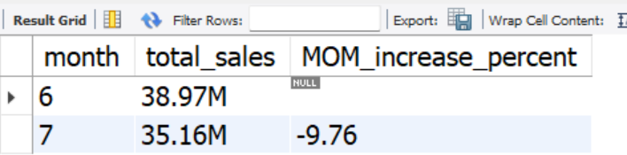

**Total Profit**

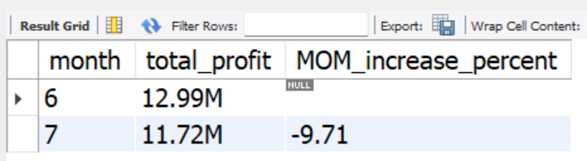

**Bottle Sold**

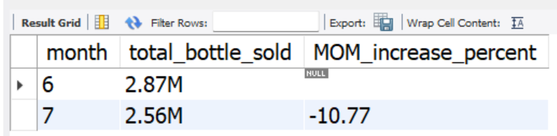

**Total Orders**

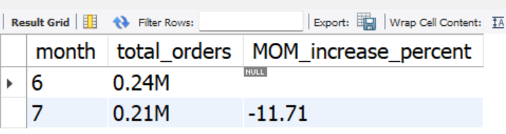

**P/S**

In the month of july(7) there is a decrease in sales by 9.76% , decrease in profit by 9.71%, decrease in bottle sold by 10.77% and decrease in total orders by from the previous month june

**B/P**

**Offer Discounts and Promotions**

* Introduce limited-time discounts (e.g Buy One Get One 50% Off).
* Provide loyalty rewards for regular customers (e.g free bottle after 10 purchases).

**Expand Product Range**

* Stock trendy or in-demand items (e.g American Vodkas, Canadian whiskey).
* Include complementary items (e.g mixers, snacks).

**Problem Statement**

* What is the Top 10 selling product category and the contributon or impact to total sales per month

**Business Problem**

* How do we focus on expanding profitable product category

**Findings**

**Top 10 Product Category**

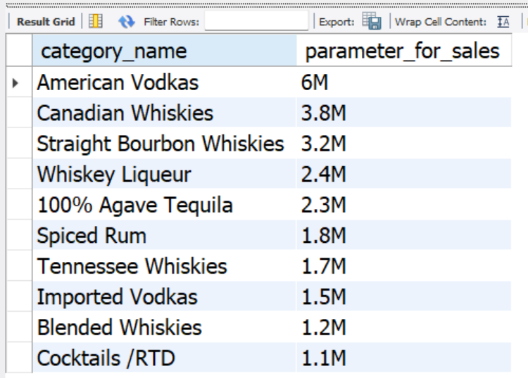

**Total Sales For Top 10 Category**

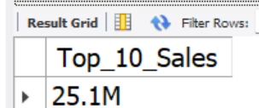

**P/S**

These above are the top 10 product category in the month of june 2021. with a total sales of $39.0M the top 10 product category contributed $25.1M whch is 64.3% of total sales Having its major impact by American Vodka which contribute 13.8% in the month of June

**B/P**

**Promotions Targeted to Popular Categories**:

* Run exclusive discounts or offers on the top-selling categories to boost repeat purchases.
* Train staff to recommend premium options within these categories to customers.

**Supplier Negotiations**:

* Negotiate better deals with suppliers for bulk purchases in these top categories.

**Problem Statement**

* What are the Top 10 lowest selling product cateroy Per month

**Business Problem**

* Identify low performing product to reduce looses and benchmark best pratice to improve underperformance

**Findings**

**Lowest 10 Category Sales**

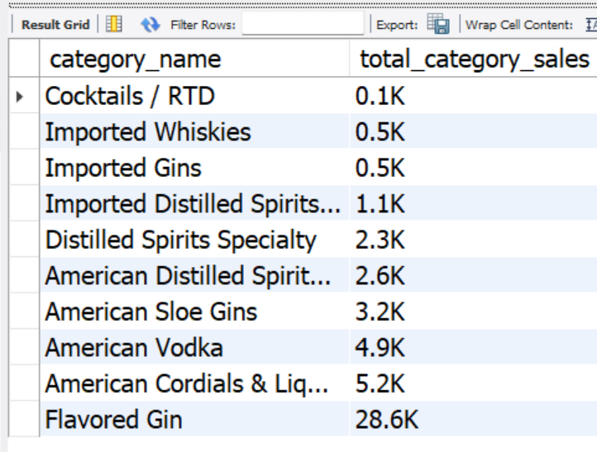

**P/S**

* This above is the lowest selling product category in the month of June. Having the lowest sales coming from Cocktails / RTD with a total of $100 sales for that month

**B/P**

**Customer Feedback:**

* Conduct surveys or interact with customers to understand why they’re not purchasing products in the category (e.g., taste preferences, price sensitivity, or lack of awareness)

**Sampling Events:**

* Host tasting sessions for products in the category to familiarize customers with them.
* Offer coupons or discounts during these events to encourage purchases.

**Problem Statement**

* What is the avg vol sold per top 10 vs Lowest 10 product category

**Business Problem**

* How does bottle volume affect sales

**Finding**

**Avg Vol Per Top 10 Category Avg Vol Per Bottom 10 Category**

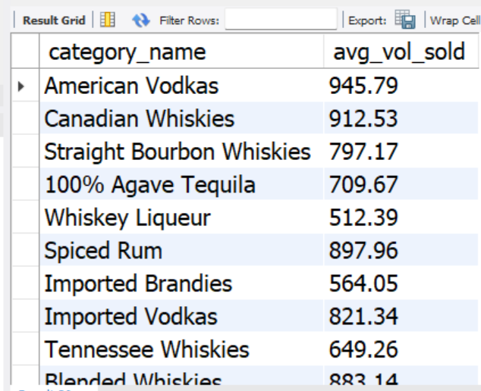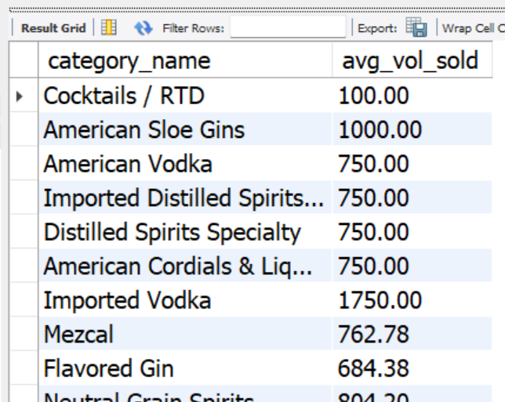

**P/S and B/P**

* The above reveals the avg bottle volum sold per product category base on top 10 and bottom 10, with the above, bottle size or volume does’nt really affect sales impact because top 10 product category and bottom to product category has a linear avg volume per bottle, hence this sales difference can be cause by different factors eg, taste, avaliabllity, customer preferences etc.

**Problem Statement**

* What is the top 5 vendor supliers per product category

**Business Problem**

* How do we negotiate product cost for the best performing product category to increase sales demands

**Findings**

Top 5 Major Product Supplier For American Vodkas

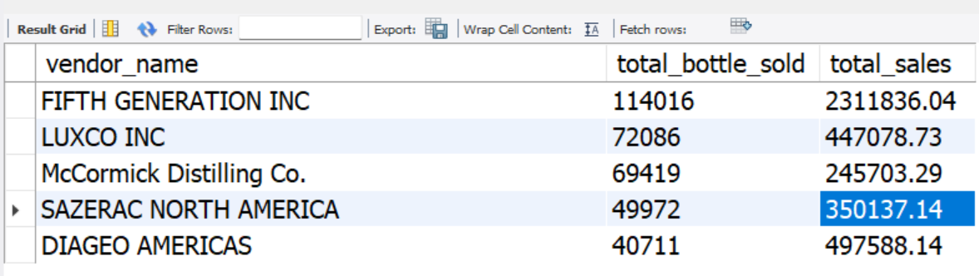

**P/S**

* The aboves shows the top 5 major product supplier (vendor) for American Vodkas having majority of sales coming from product supply by vendor FIFTH GENERATION INC generating a total of $2.3M sales in the month of May

**B/P**

**Supplier Incentives**

* Commit to longer-term contracts for guaranteed orders over months or quarters in exchange for price reductions.

**Problem Statement**

* What is the top 10 county and its contribution to total sales per month

**Business Problem**

* How do we strategically allocate resource to high performing county

**Findings**

**Top 10 County**

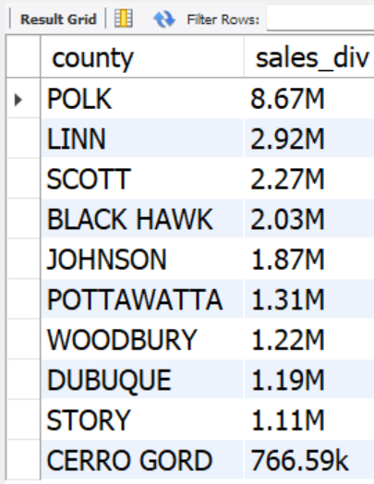

**Total Top 10 County**

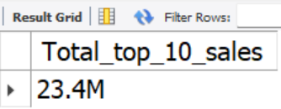

**P/S**

* Above is the top 10 county in the month of april . with a total sales of $34.7m the top 10 county contributed $23.4M in sales having the major sales impact by POLK which contibute 25.0% of total sales of that month

**B/P**

**Retail Expansion**

* Open new stores or expand existing ones in high-performing counties to serve more customers.
* Upgrade store infrastructure and layouts to enhance the shopping experience**.**

**Problem Statement**

* What is the lowest 10 underperforming counties per month

**Business Problem**

* How can we improve sales in the underperforming counties

**Findings**

**Lowest 10 counties**

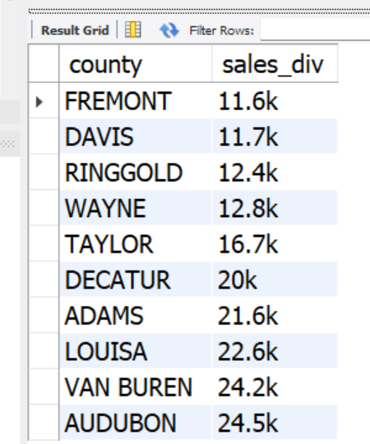

**P/S**

* The above is the lowest 10 performing counties in the month of April, having the lowest sales coming from **FREMONT** with a total of $11.6k for that month (April)

**B/P**

**Localized Marketing Campaigns**

* Use region-specific advertising with messages that resonate with the local audience

**Demand-Driven Stocking**

* Use sales data and customer feedback to identify the most desired products in the region.
* Introduce new product lines tailored to the county’s demographics.

**Problem Statement**

* What is the sales generated overtime in a certain month and which day contibute more to sales

**Business Problem**

* Determine which day of the week impact sales revenue in order to adjust and optimize stocking

**Findings**

**Sales by Weekdays**

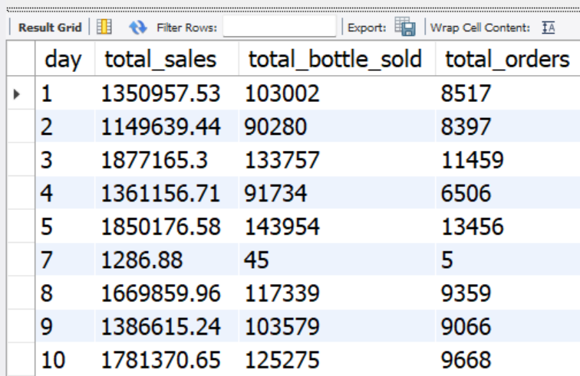

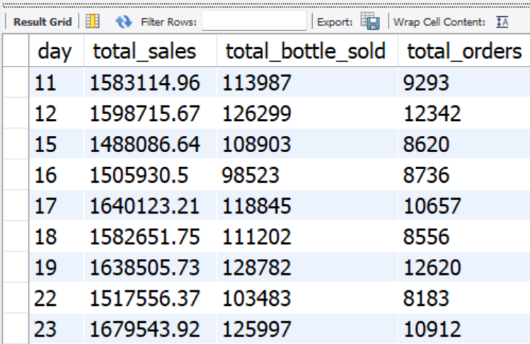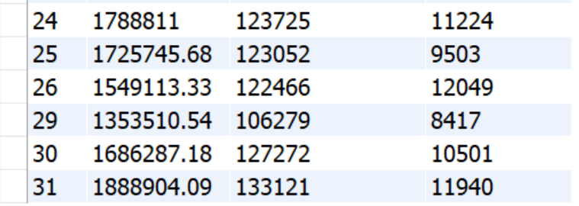

**P/S**

* The above is sales generated over time in the month of May, on this month every wenesdays contribute more to sales in a week with over $1.7M sales per week of that month

**B/P**

**High-Performing Days**

* Increase stock levels for popular products to prevent stockouts.
* Prioritize fast-moving items and promotional products.
* Ensure staff availability to manage increased customer traffic.

**Low-Performing Days**

* Reduce stock levels of perishable or low-demand products.
* Test promotions to boost traffic on these days